**Lineweaver-Burke**

1/v = Km/Vm * 1/[S] + 1/Vm

**Eadie Hofstee**

V = -Km * V/[S] + Vm

**Hanes**

[S]/V = [S] * 1/Vm + Km/Vm

Max reaction rate directly related to [enzyme]

**Integration of M&M Equation**

Cm * ln(CA0/CA) + (CA0 - CA) = k3CE0

First order term + zero order term = Vm

CA0 - CA / ln(CA0/CA) = -Cm + k3CE0t/ln(CA0/CA)

**Inhibitors**

Balance metabolic reaction

**Suicide Inhibitors**

Bind permanently to enzyme

**Allosteric**

Bind to site other than active site to inhibit reaction

pH, temperature, environmental changes considered inhibitors? No --> only those which change reaction *mechanism*

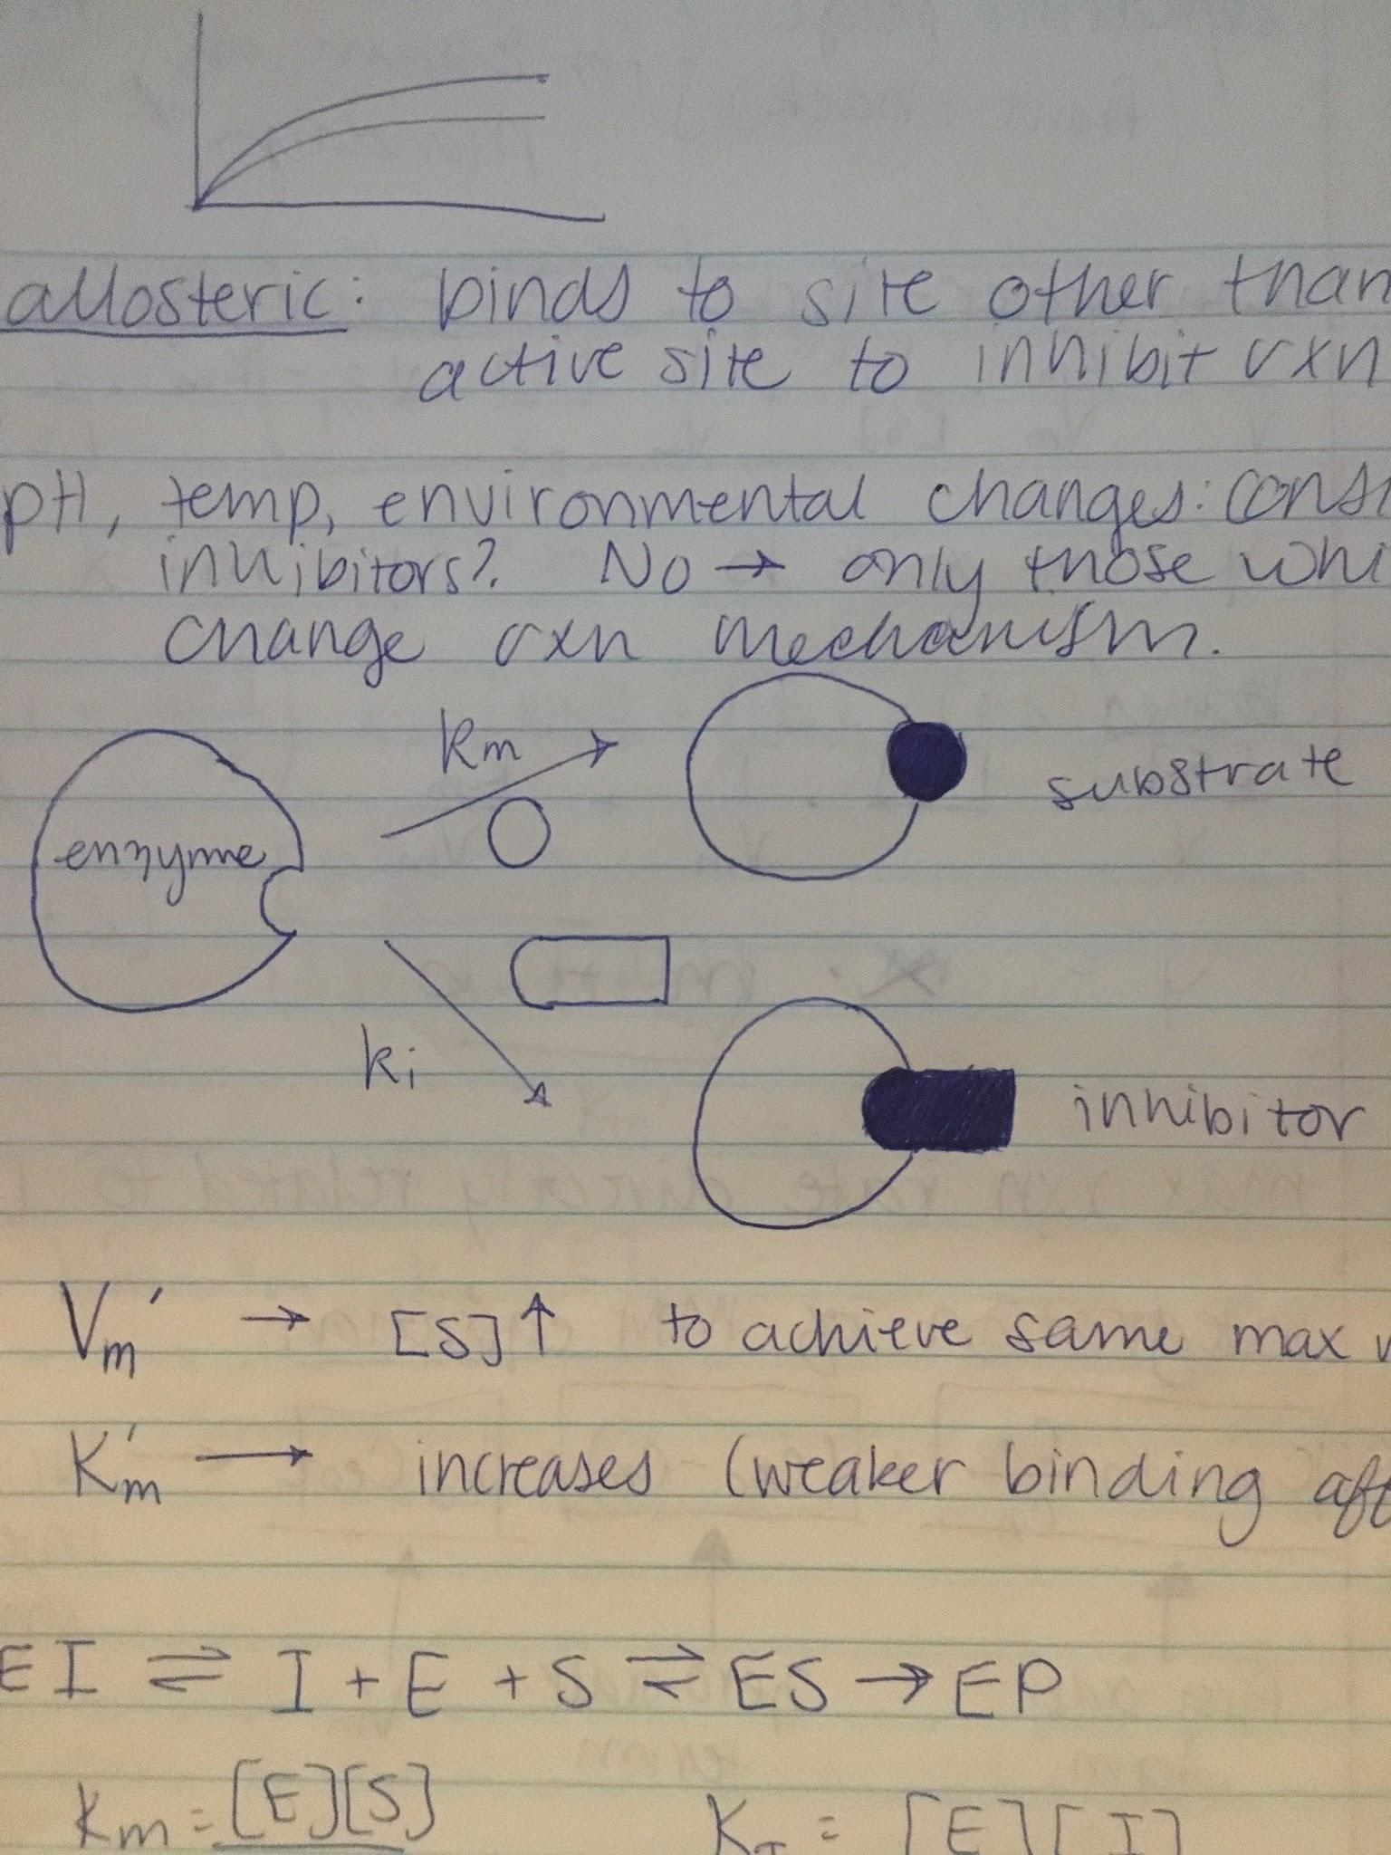

Vm’: [S]↑ to achieve same max reaction rate

Km’: increases (weaker binding affinity)

EI <--> I + E + S <--> ES --> EP

Km = [E][S]/[ES]

Ki = [E][I]/[EI]

[E0] = [E] + [ES] + [EI] = [E] + [ES] + [E][I]/ki

V = k3[ES]

[E] = [E0] - [ES] / 1 + [I]/ki

[ES] = ([E0] - [ES] / 1 + [I]/ki) [S] / km

(1 + [I]/ki) km[ES] = ([E0] - [ES])[S]

[ES] = [E0][S]/([S]+km(1+[I]/ki)/km)

Vm’ = Vm = k3[E0]